|  |  |
| --- | --- |
| **AGENDA - Little Hoole Parish Council**  *Members of the Council are summoned to the Parish Council Meeting to be held on  Mon 13th Jan 2025 at 7:00pm*  ***The Lounge, Old Mill Court Retirement Housing, Liverpool Old Road, Walmer Bridge, PR4 5QU*** Paul Cafferkey, Clerk & Responsible Financial Officer |  |

1. Apologies for absence
2. To agree the Minutes of the last Parish Council Meeting
3. To receive declarations of interest
4. Matters arising from the minutes of last meeting
   1. Public Time: to invite and listen to issues raised by members of the public
   2. Planning Applications:
5. 07/2024/00854/HOH. 57A Liverpool Old Road Walmer Bridge PR5 5QA. Single Storey Rear Extension.
6. 07/2024/00773/FUL. 67B Liverpool Old Road Walmer Bridge PR4 5QE. Alterations to shop front.  
   1. To approve the following transactions in the bank for Dec 2024:

|  |  |  |  |
| --- | --- | --- | --- |
| Date | Payee | £ | Description |
| Current a/c | | | |
| 02-Dec-24 | Direct Debit (GOCARDLESS) | 36.96 | Monthly website fee |
| 02-Dec-24 | B/P to: Festive Lights | 18.41 | Christmas Lights |
| 03-Dec-24 | B/P to: McCluskey Window | 25.00 | Cleaning of Bus Shelters |
| 03-Dec-24 | B/P to: Walmer Bridge VH | 50.00 | Room hire July & Sept |
| 03-Dec-24 | B/P to: L T Dryden | 170.00 | Refund Cllr Dryden re pyt to A Watson re put up Christmas Lights, tidy Ego Roundabout, Community Garden |
| 09-Dec-24 | B/P to: Peter Ashby | 119.15 | Refund to Cllr Ashby re purchase of Christmas Lights |
| 16-Dec-24 | B/P to: Paul Cafferkey | 59.99 | Refund Clerk re annual MS365 subscription |
| 16-Dec-24 | B/P to: L T Dryden | 146.09 | Refund Cllr Dryden re purchase of reflective tags for Little Hoole Primary School pupils |
| 16-Dec-24 | B/P to: Paul Cafferkey | 147.65 | Clerk's pay for tax mth 09 |
| 16-Dec-24 | B/P to: Paul Cafferkey | 1.65 | Clerk's expenses for tax mth 09 |
| 31-Dec-24 | Service Charge | 6.00 | Monthly bank charge |
| Instant Access a/c | | | |
| 31-Dec-24 | Credit Interest | -131.09 | Income from Interest |

* 1. Payments for approval - Clerk’s claim for Dec 2024
  2. Payments approved by email or pre-approved and retrospectively noted – None.
  3. To receive the Clerk’s Financial Statement report as at 30th Dec 2024
  4. To agree transfer of monies from Parish Council current a/c to Parish Council Instant Access a/c.
  5. Receipt of CIL (Community Infrastructure Levy) income - confirmation
  6. Bus Service consultation – Update
  7. Groundwork re play equipment, Dob Lane Recreation Park
  8. To discuss flooding (culvert)
  9. “In The Know” Newsletter from Lancashire Police
  10. To discuss Lancashire Road Safety “Speed Concern” submission
  11. PTA Grant – Update
  12. To discuss adoption of .gov.uk email addresses
  13. To confirm meeting dates for 2025
  14. Information and Updates.
  15. Correspondence – if applicable
  16. To agree the date, time, and venue for the Feb 2025 meeting.

**Members of the public are welcome to attend meetings to raise any relevant matters. Alternatively, if you cannot attend the meeting but wish to raise a matter or ask a question, this can be done on your behalf by contacting the Parish Clerk (Paul Cafferkey) via email at** [**clerk@littlehooleparishcouncil.org.uk**](mailto:clerk@littlehooleparishcouncil.org.uk) **or mobile phone 07966267186.**

Scan me to go the Little Hoole Parish Council Website, or visit <https://www.littlehooleparishcouncil.org.uk/>

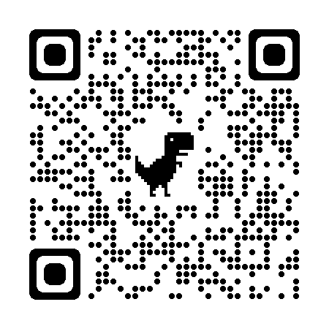

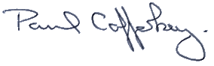Prepared and approved by Paul Cafferkey, Clerk – Little Hoole Parish Council,   
8th Jan 2025